# EXPERIMENT-5

**Student Name:** Saksham Kumar **UID:**22BET10333

**Branch:** BE -IT **Section/Group:**22BET_IOT-703(B)

**Semester:** 6th **Subject Code:** 22ITP-351

# PROBLEM-1

**AIM:-**

Longest Increasing Subsequence

## CODE:-

public class Solution {

public int lengthOfLIS(int[] nums) {

if (nums == null || nums.length == 0) { return 0;

}

int n = nums.length; int[] dp = new int[n]; Arrays.fill(dp, 1); for (int i = 1; i < n; ++i) { for (int j = 0; j < i; ++j) { if (nums[i] > nums[j]) {

dp[i] = Math.max(dp[i], dp[j] + 1);

}

}

}

int maxLength = Arrays.stream(dp).max().orElse(0); return maxLength;

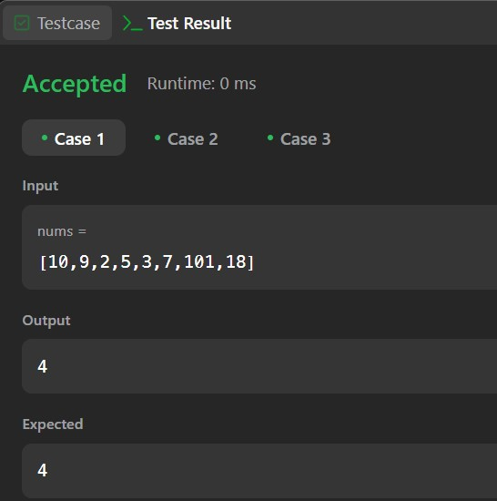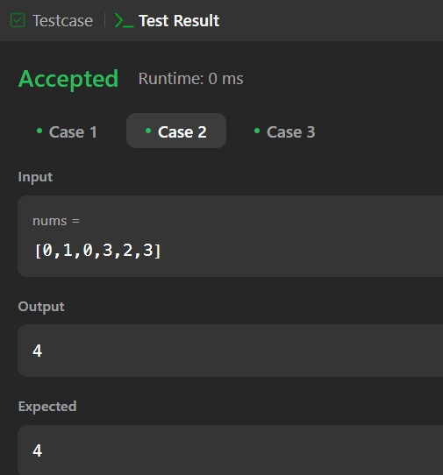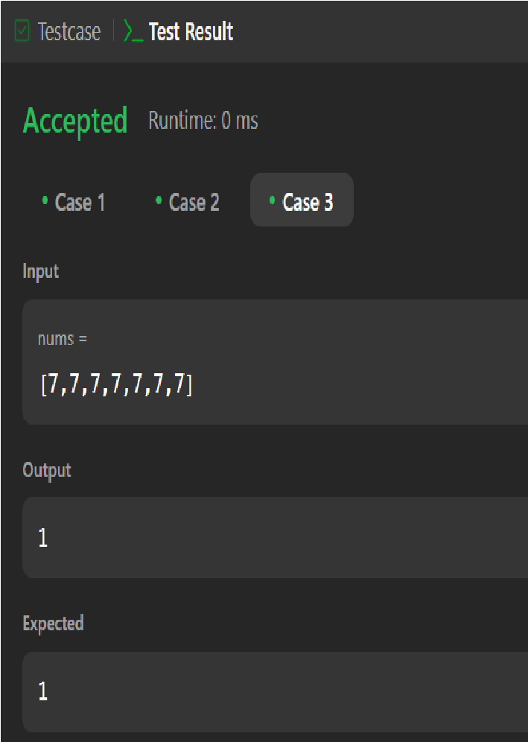

}

}

**OUTPUT:-**

# PROBLEM-2

**AIM:-**

Maximum Product Subarray

## CODE:-

class Solution { public int maxProduct(int[] nums) { int res = Integer.MIN_VALUE;

for (int n : nums) { res = Math.max(res, n);

}

int curMax = 1, curMin = 1;

for (int n : nums) { int temp = curMax * n; curMax = Math.max(temp, Math.max(curMin * n, n)); curMin = Math.min(temp, Math.min(curMin * n, n));

res = Math.max(res, curMax);

}

return res;

}

}

**OUTPUT:**

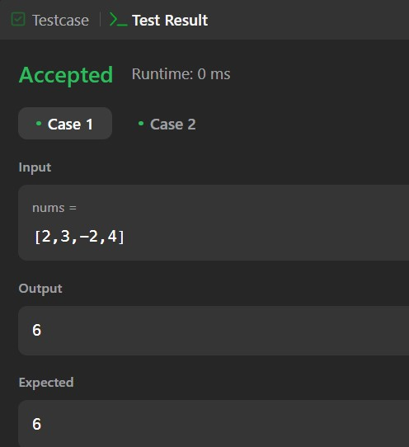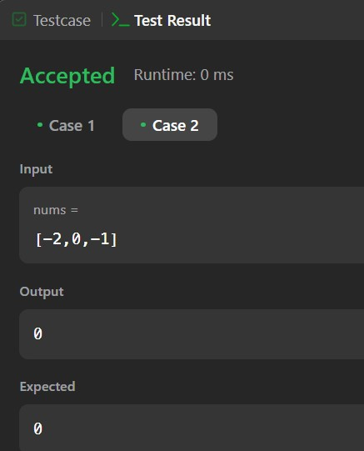

**PROBLEM-3**

## AIM:- Decode Ways CODE:-

class Solution { public int numDecodings(String s) { if (s.charAt(0) == '0') {

return 0;

}

int n = s.length(); int[] dp = new int[n + 1];

dp[0] = dp[1] = 1;

for (int i = 2; i <= n; i++) { int one = Character.getNumericValue(s.charAt(i - 1)); int two = Integer.parseInt(s.substring(i - 2, i));

if (1 <= one && one <= 9) { dp[i] += dp[i - 1];

}

if (10 <= two && two <= 26) { dp[i] += dp[i - 2];

}

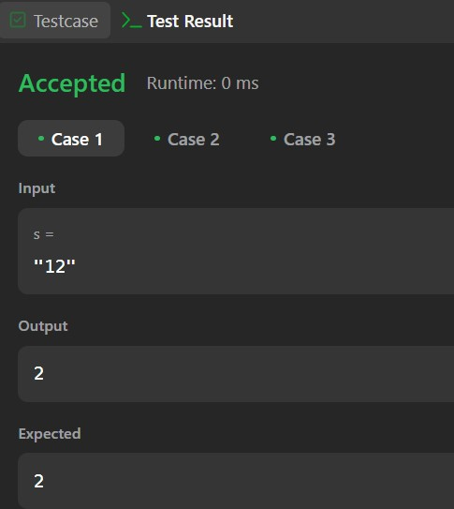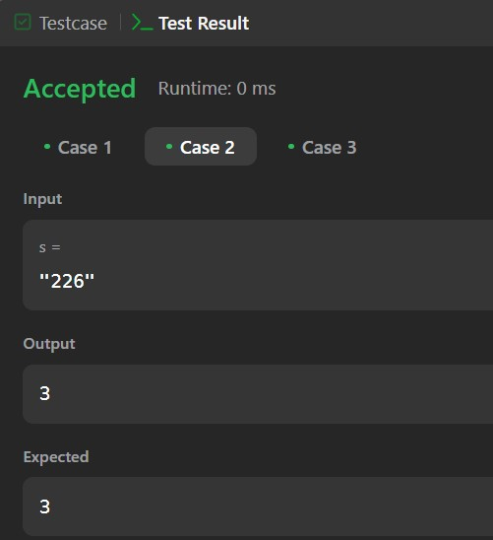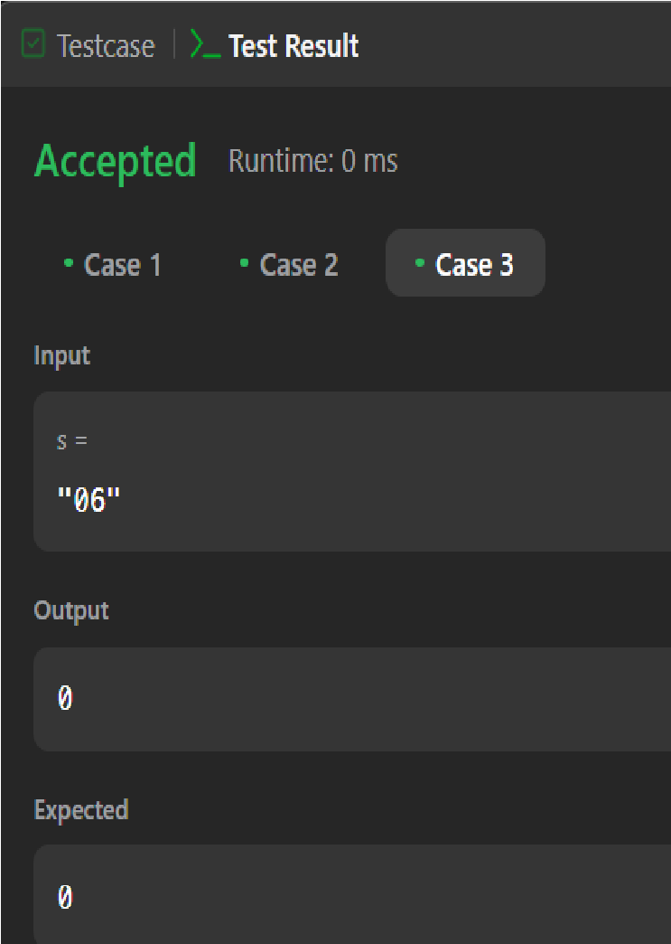

}

return dp[n];

}

}

**OUTPUT:-**

# PROBLEM-4

**AIM:-**

Best time to buy and Sell a Stock with Cooldown

## CODE:-

class Solution {

public int maxProfit(int[] prices) {

int coolDown = 0, sell = 0, hold = Integer.MIN_VALUE; for (int stockPrice : prices) { int prevCoolDown = coolDown, prevSell = sell; coolDown = Math.max(prevCoolDown, sell);

sell = hold + stockPrice;

hold = Math.max(hold, prevCoolDown - stockPrice);

}

return Math.max(coolDown, sell);

}

}

## OUTPUT:-

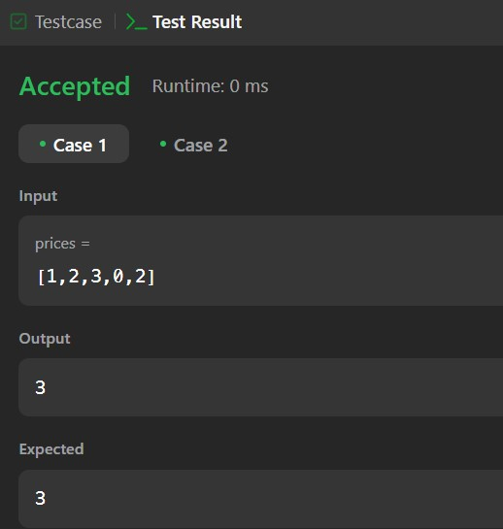

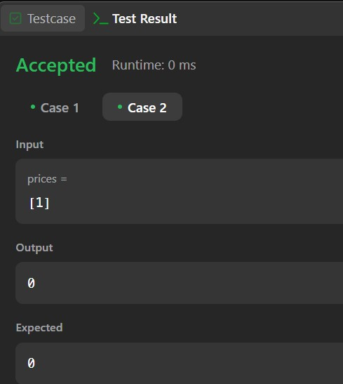

# PROBLEM-5

**AIM:-**

Perfect Squares

## CODE:-

class Solution { public int numSquares(int n) {

int[] dp = new int[n + 1];

Arrays.fill(dp, Integer.MAX_VALUE); dp[0] = 0;

for (int i = 1; i <= n; ++i) {

int min_val = Integer.MAX_VALUE;

for (int j = 1; j * j <= i; ++j) {

min_val = Math.min(min_val, dp[i - j * j] + 1);

}

dp[i] = min_val;

}

return dp[n];

}

}

## OUTPUT:-

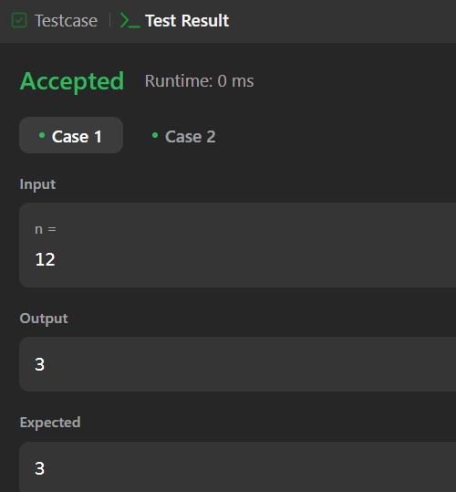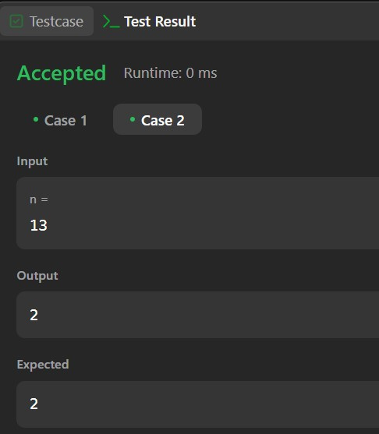

# PROBLEM-6

## AIM:- Word Break CODE:-

class Solution {

public boolean wordBreak(String s, List<String> wordDict) { int n = s.length();

boolean[] dp = new boolean[n + 1]; dp[0] = true; int max_len = 0;

for (String word : wordDict) {

max_len = Math.max(max_len, word.length());

}

for (int i = 1; i <= n; i++) {

for (int j = i - 1; j >= Math.max(i - max_len - 1, 0); j--) {

if (dp[j] && wordDict.contains(s.substring(j, i))) { dp[i] = true; break;

}

} } return dp[n];

}

}

## OUTPUT:-

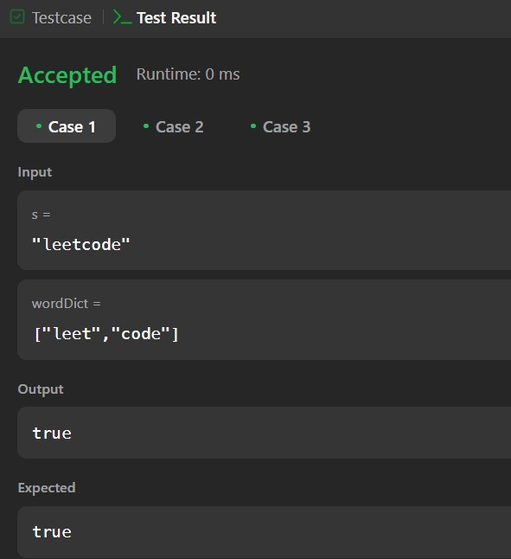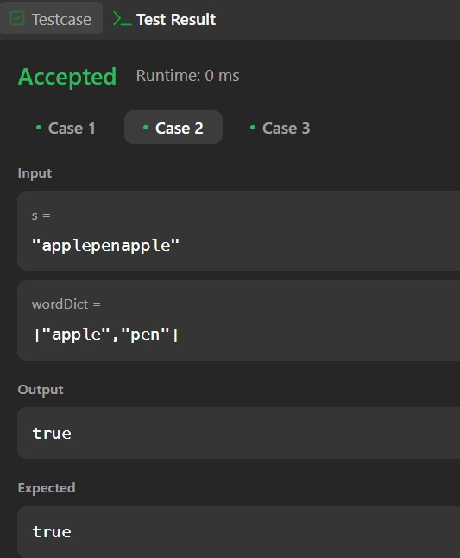

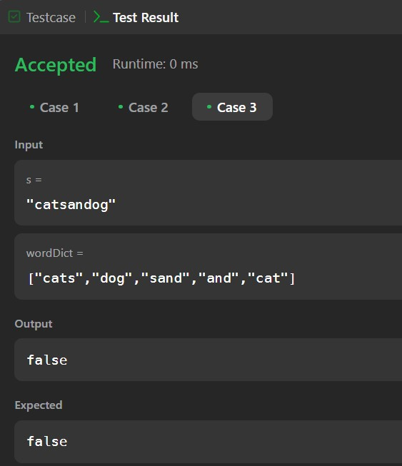 **PROBLEM-7**

## AIM:- Word Break 2 CODE:-

class Solution {

public List<String> wordBreak(String s, List<String> wordDict) { int n = s.length();

Set<String> wordSet = new HashSet<>(wordDict); List<List<String>> dp = new ArrayList<>();

for (int i = 0; i <= n; i++) {

dp.add(new ArrayList<>());

}

dp.get(0).add(""); for (int i = 1; i <= n; i++) {

List<String> temp = new ArrayList<>(); for (int j = 0; j < i; j++) {

String suffix = s.substring(j, i); if (wordSet.contains(suffix)) { for (String substring : dp.get(j)) {

temp.add(substring + (substring.isEmpty() ? "" : " ") + suffix);

}

} }

dp.set(i, temp);

}

return dp.get(n);

}

}

## OUTPUT:-

